

SYMBIOSIS INTERNATIONAL (DEEMED UNIVERSITY)
(Established under section 3 of the UGC Act 1956)
Re-accredited by NAAC with “A” Grade

Name of the Student: Sneha Sah PRN: 25070122189
Semester: 3 Year: AY 25-29

ASSIGNMENT No: 13

TITLE: Write a Java program to perform reading from and writing to a file using file handling operations.

Problem Statement:
Write a Java program to perform reading from and writing to a file using file handling operations.

Theory: Java provides file handling through the java.io package. Classes such as File, FileReader, FileWriter, BufferedReader, and BufferedWriter are used to perform input and output operations. File handling enables permanent storage and retrieval of application data. Proper exception handling is necessary to manage file-related errors. These concepts are essential for data persistence.

Exercise
- Create a program to write and read employee details from a file.

Source code:
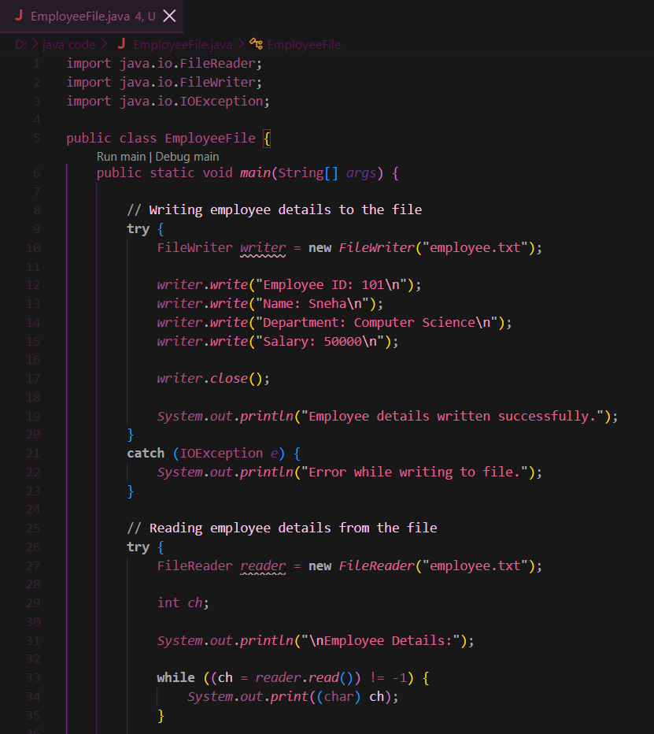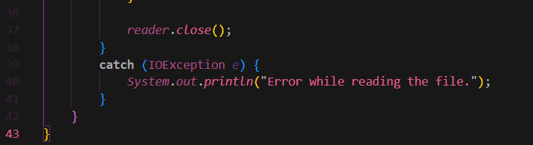

Output:
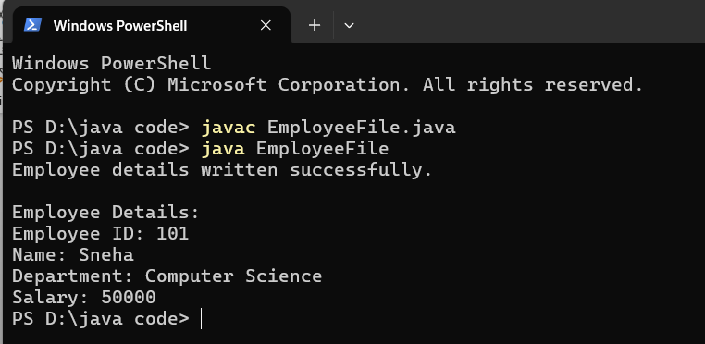
- Create a Java program to write patient details (patient ID, name, age, and diagnosis) to a file and read the details from the file for display.
Source code:
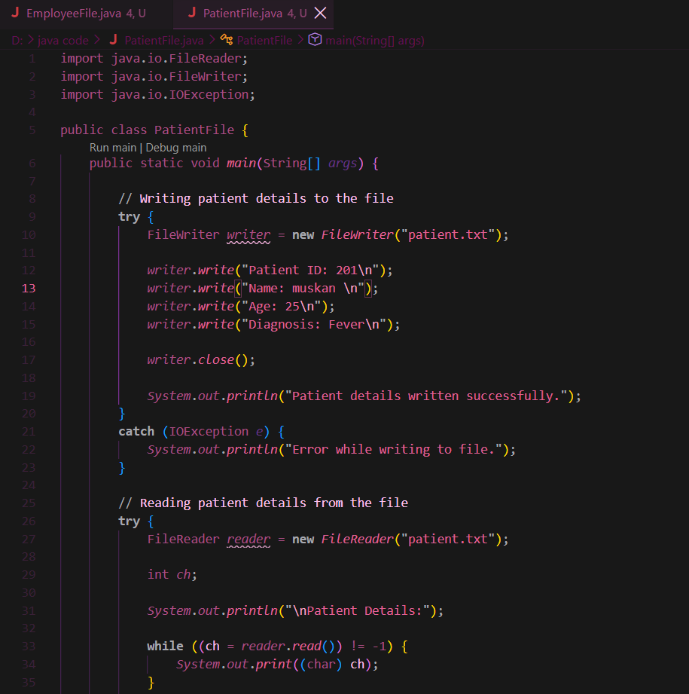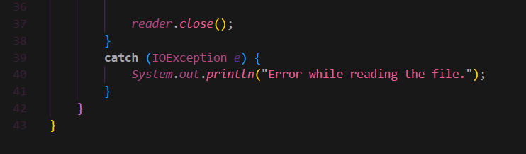
Output:
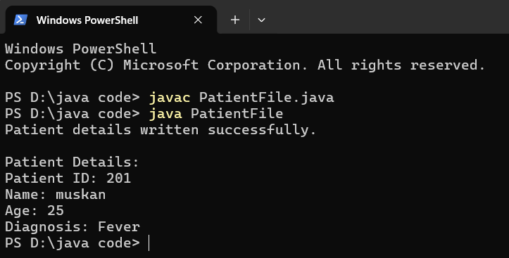
Conclusion
Thus, the experiment was successfully completed using Java file handling operations. We learned how to write employee and patient details into files using FileWriter and read the stored information using FileReader. The experiment also demonstrated the use of exception handling to manage file-related errors.

